Doshwise

**About**

My app is called Doshwise. Dosh meaning money and wise meaning smart, together meaning being smart about money. This story behind this app is to make living with people easier. I know, and you know, we have all had roommates, friends or partners who hate talking about money, and when you bring it up it only causes stress in the household. Stress which can be easily avoided by using an app like Doshwise.

**What Doshwise Does**

Doshwise when on first start-up will contain a few screens will short Getting Started messages. Which will give the user a small outline on what the app does.

Doshwise will allow you to create a household with a name of your choosing and the number of people living in the house. Each person will have a name to make it easier people distinguish between throughout using the app. When creating a household, you will also enter the monthly rent amount, which will be at a fixed price unless edited manually.

Doshwise’s main home screen will allow functionality for adding expenses, other than the monthly rent, to the total amount for the current month. Other expenses available to add will be electricity, water and general expenses which may include damages to the house which may affect everyone. The total for the current month’s bill will always be shown to the user on the home screen.

Doshwise will have a screen which will allow you to view a breakdown of all expenses, paid and unpaid for this month or previous months. This will make it easier to see a history of who paid what amount of what expense before today, and what expenses are being paid for this month.

Doshwise will have a screen which will do all calculating of expenses for you at the end of every month. This function will allow for easy managing of who pays what amount of what. When adding an expense, the people in the household who are involved in the expense are chosen. The total for each person in the household to pay will be calculated based on the total amount for this month and who is included in what expense.

**Design**

When deciding what design approach I should implement with Doshwise, I ended up on Googles design process called Material Design. Material Design will make the app stand out using iconography and bold colours. The colour scheme I decided to go for is a blue, grey, white colour scheme, which I think is very easy on the eyes and provide the least possible strain for users while maintaining a minimalistic feel.

Colour Codes:

#C9C9C9 : #FAFAFA : #9AD3DE : #89BDD3

The application will be designed in both portrait and landscape for each activity. Portrait containing a more condensed view and less details. Landscape giving the user more details in relation to for e.g. bill details. Below are prototyped visualisations of each screen for Doshwise.

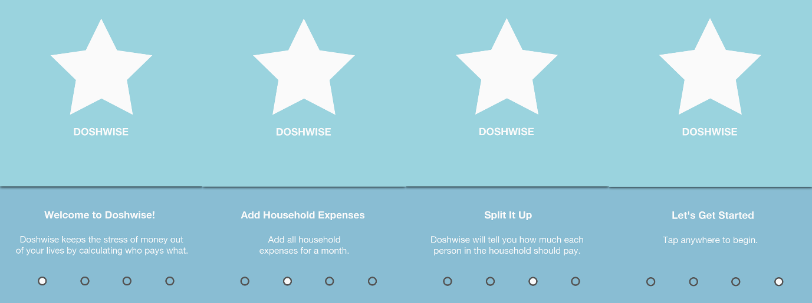

Here is an image showing the four welcome screens. Each screen displays a message explaining a little bit about what Doshwise does. The stars represent where the Doshwise logo will go.

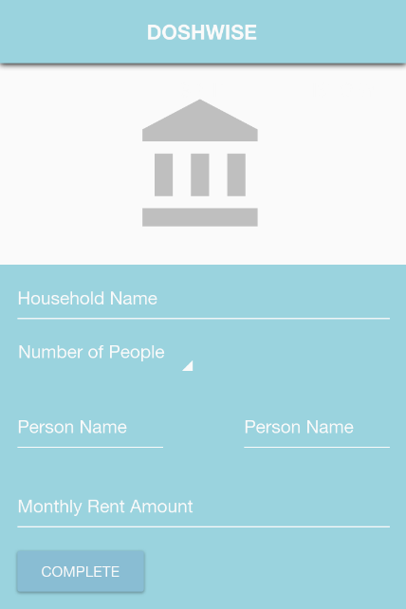

Here is an image showing the use of Text Fields for the user to enter the required information. There is also a Spinner being used to choose the amount of people which live in the household.

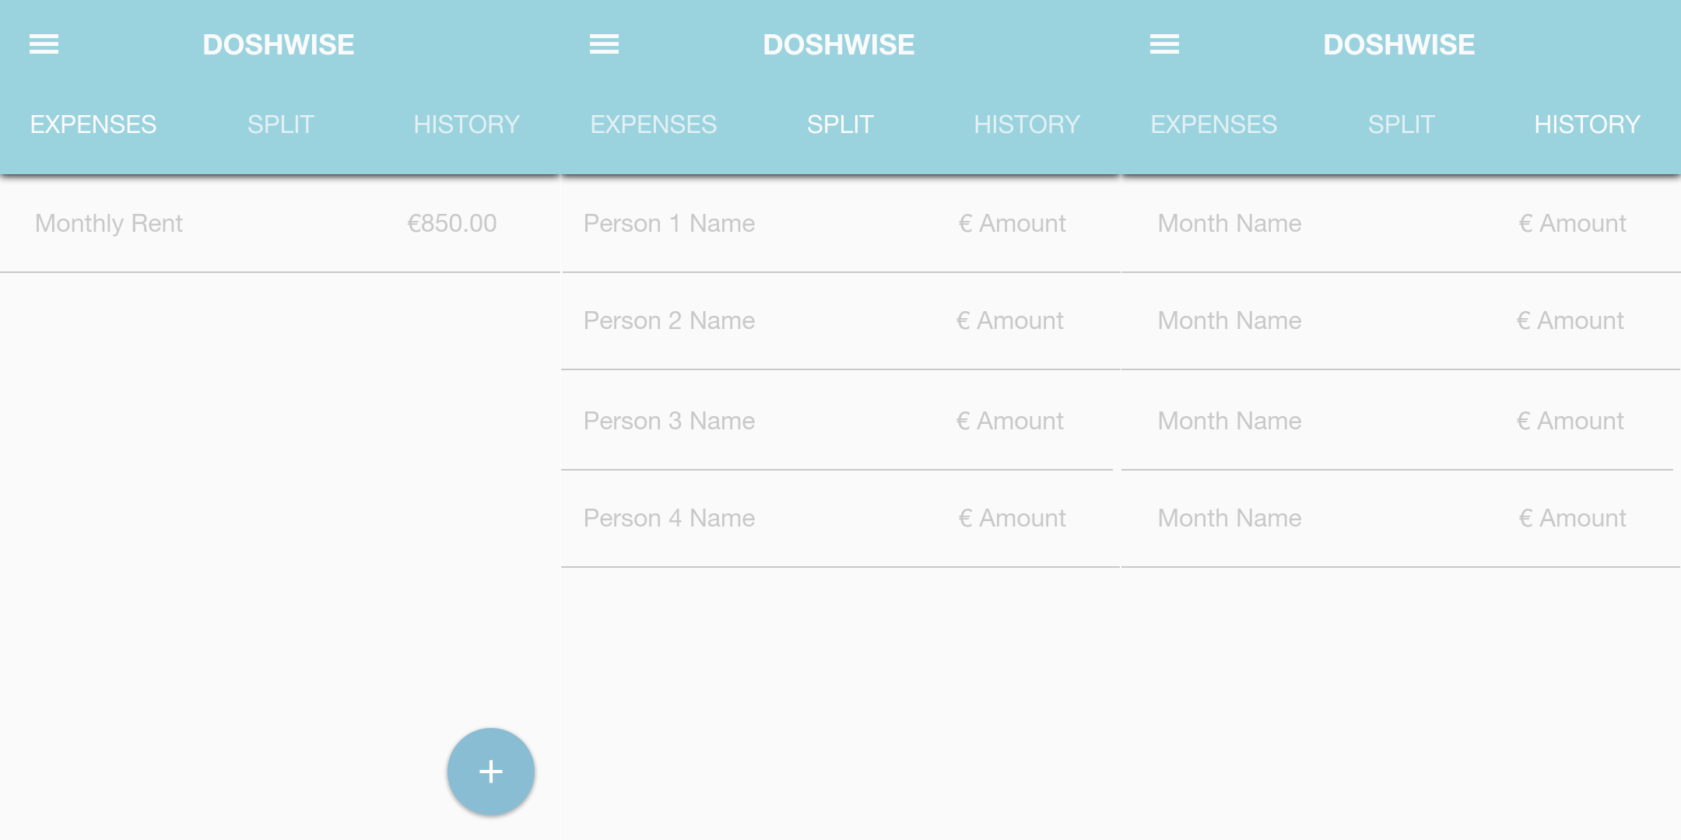

Here is an image showing the three main screens within the application. Tabs will be used to navigate between each screen. An Action Button will be used for creating expenses.

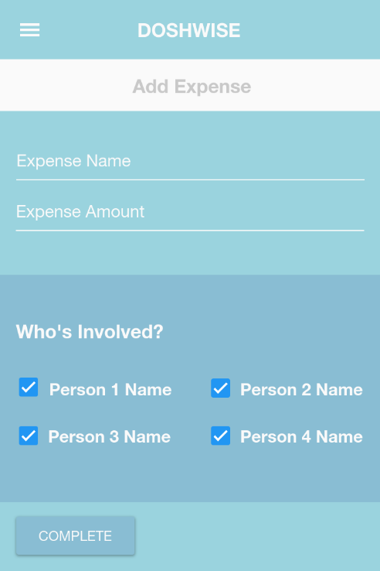

Here is an image showing the screen for adding an expense. Again, there will be a use of Text Fields. The people involved in an expense will be chosen using Checkboxes. To complete an entry there will be a Raised Button.

**Market Share Statistics**

The category which my mobile application will fit into will be the Finance Category. There are only 2 apps in the Finance category which I can find related to Rent Splitting. The names of the apps are; ‘*Spittable*’ and ‘*Splitwise*’. There is a huge number of applications that can be downloaded for expense managing, which targets all users. Whereas Doshwise targets people in house sharing situations. With the right features and marketing strategy, the app could easily gain attention and build a large audience in this market. People are always looking for easier ways to manage their money and the best way to do that is with mobile apps. The problem with expense managing applications is that they come with a lot of additional features which will only leave the user feeling confused while checking the see what the features are that they will use. Doshwise will be simple and focused towards only one task, household bill splitting between roommates. Therefore, there is a market available for applications like Doshwise.

**Platform Transitions and Marketing Strategies**

Doshwise will be initially developed for Android and released on the Google Play Store, as the Google Play Store is the largest application store to date. Although when successful, further development of the app across multiple platforms will go ahead. The app will be redeveloped from scratch for iOS, objective-C, and Microsoft phones, C/C#, and will be available through their relevant application stores. Another platform which Doshwise will be released on would be Amazon App Store, which some people use as an alternative to the Google Play Store. For further exposure of Doshwise, a website will be developed which will contain information about Doshwise and have direct links to download Doshwise for the currently available platforms. Monetisation, which I will speak about later, will not change throughout each platform.

To advertise Doshwise, social media would be the ideal route. All successful applications are advertised using this method as it is the most effective method. The main social media platforms would be the likes of Facebook, Twitter and YouTube. A Facebook page will be made for the application and shared across other online websites, the same applies for Twitter. YouTube in my opinion, is the most powerful marketing tool. Paying YouTube to advertise Doshwise to a relevant viewer base on user’s videos will be a huge contributor to the success of the application.

**Beta Testing**

After making progress with the development of Doshwise, beta testing would be the first biggest step into the public eye. Getting user feedback is the biggest part of retaining a user base and keeping new users on board. Beta testing can begin once Doshwise reaches the MVP (Minimum Viable Product) stage, that way all further development will be geared in the right direction. The distribution channels mentioned earlier like, Google Play Store and Amazon App Store would be the platforms the beta would be available in as it is the first platform the application will be developed for. Engaging in local beta testing at local collages for students would also be a great way to test Doshwise, as most students would be in a situation where they are sharing with other people.

**User Interaction**

User interaction is the biggest obstacle which a lot of applications fail to succeed in. Making a user feel confused with how to user the application results in the application being uninstalled right away.

On initial start up the user is greeted with 4 getting started screens. The user reads each message while swiping to the left, or right if they wish to go back, until getting to the message prompting them to “Tap Anywhere to Get Started” taking them to the household setup screen.

Here the user simply enters some basic details about the household they wish to use with Doshwise and presses a single button to continue to the expenses screen, which will be the main activity.

From the expenses screen the user is presented with 3 different tabs to which they can switch between, the current one being expenses as mentioned. From the expenses screen they can add expenses through the pressing of a single button which will take them to the add expenses screen to enter basic details.

All screens will be accessible through tabs.

The next tab would be the ‘*split’* tab which will provide a user-friendly breakdown of how much each person pays for the current month. No user-interaction here.

The last screen is the ‘*history’* tab which will show all previous months amounts for bills for easy comparison to the upcoming months. No user-interaction here.

**Monetisation Strategies**

In further development, Doshwise could implement a premium version, which will allow all bills to be paid through the Doshwise application itself. Making the users life’s easier and more convenient.

Doshwise would be released on all platforms as freemium as it is the most profitable pricing strategy for applications. Providing in application purchases such as the premium version of the application mentioned above would be the best idea for Doshwise to make profit. Freemium will give the user a feel for the application before deciding to invest any money into a premium version.

The biggest monetisation strategy for Doshwise would be integrating other applications advertisements. Other application development companies could pay a small fee to have their application advertised in a non-user impeding way which would benefit Doshwise hugely.

When a user has opted for premium and uses Doshwise to pay for bills, a small part of the transaction fee could be taken by Doshwise to increase profits.

**Conclusion**

As delineated in this document, I believe that Doshwise has potential for further ideas and to make a successful and profitable application. Doshwise sits nicely into a niche target market which I believe will increase the exposure of the application and provide a high satisfaction to all users.­